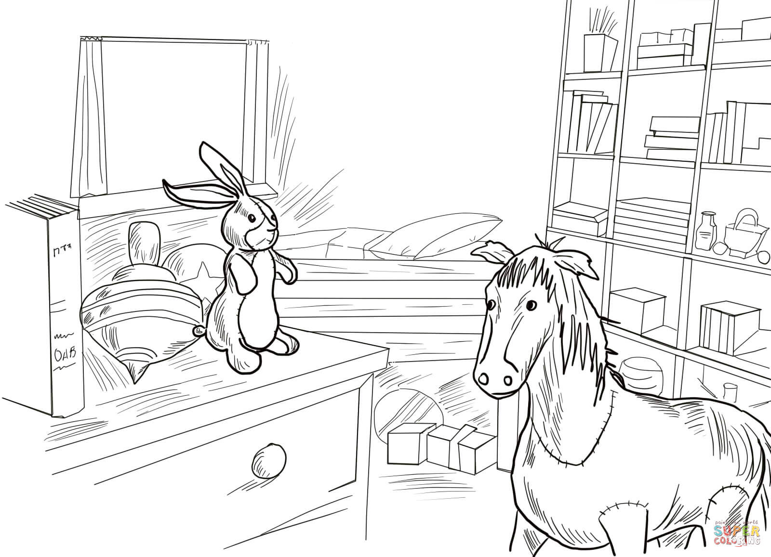

**Family Discussion Guide**

for

*The Velveteen Rabbit* by Margery Williams

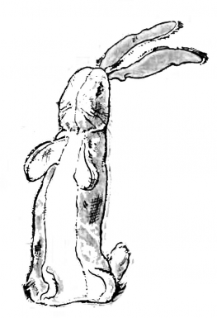

Transformed by love,

because everyone deserves to be Real.

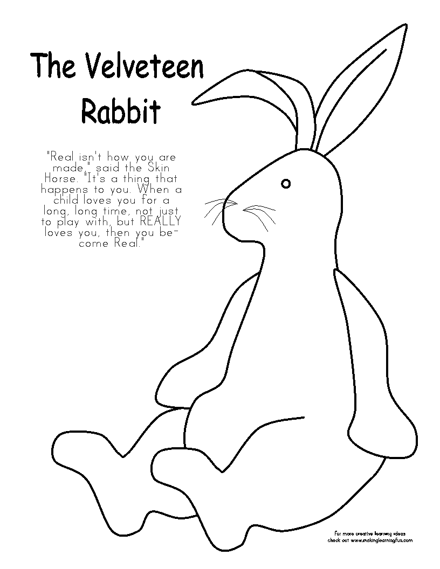

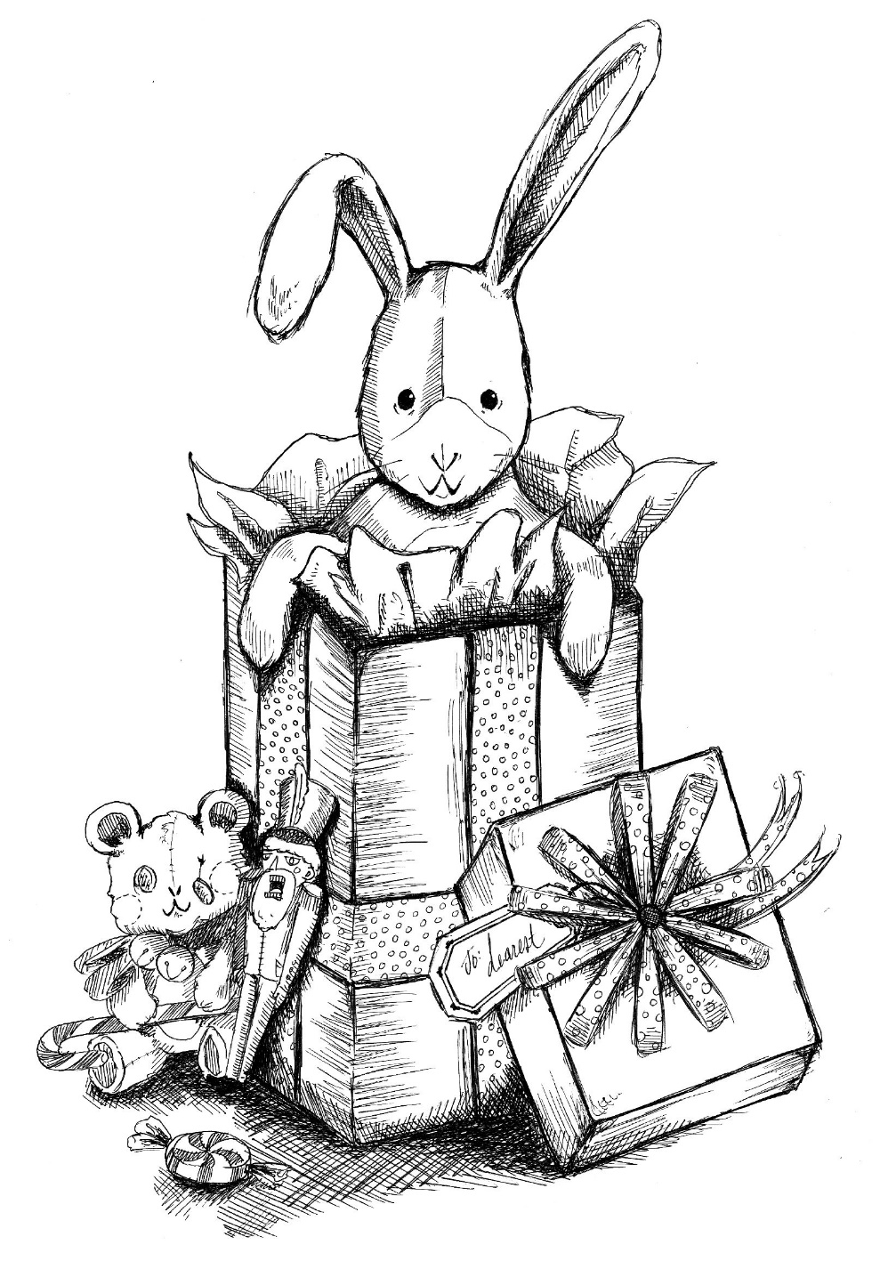

When I was a child, the Reverend Robert M. Butler read

*The Velveteen Rabbit* to the entire parish in a sermon series.

I remember being enthralled. He shared the book’s message of love to an Episcopal church in Northern Maine. This *Family Discussion Guide* is my endeavor to pass along this legacy and message to other parishes.

I encourage you to read *The Velveteen Rabbit* book with your children. Magic happens when a story draws parent and child into a world of make-believe. Reading together is a precious gift of time that feeds the soul and nurtures the heart.

Gail M. Jackins, M.Ed.

Houston, TX

**Love and Eternity in *The Velveteen Rabbit***

Open up *The Velveteen Rabbit* and find a message for your soul, a parable about love.

*The Velveteen Rabbit* sparks our soul to imagine love and eternity in an inspiring and transformative way. Through this classic book, we can learn more about ourselves, our relationship with others, and our relationship with God.



*“What is REAL?” asked the Rabbit. “When a child loves you for a long, long time, not just to play with, but REALLY loves you, then you become Real,” said the Skin Horse, a wise toy in the nursery.*

Being Real for the Rabbit is about wanting to be loved. We don’t have to wait for love. Ephesians 1:4 tells us, “Before God made the world, he loved us.”



*The Skin Horse had lived longer in the nursery than any of the others . . . he was wise.*

The Skin Horse is old and wise, so the Rabbit listened carefully to him. I Timothy 5:17 instructs us “Wise elders are to be considered worthy of double honor.”



*“Once you are Real,” the Skin Horse said, “you can’t become unreal again. It lasts for always.”  The Rabbit sighed. He longed to become Real, to know what it felt like.*

The Rabbit longed to be truly loved. God’s love for us is unconditional and eternal. Romans 8:38-39 teaches us “that neither death, nor life, nor angels, nor rulers, nor things present, nor things

2

 have a conversation with someone who is old and wise like the Skin Horse. Visit an elderly friend, or Veteran, or parishioner.

 very young children enjoy hopping like bunnies. Hop with them. Wiggle your nose and tail like a bunny, too.

 bunnies love carrots. Have a snack of carrots and ranch dressing or hummus while talking about the book

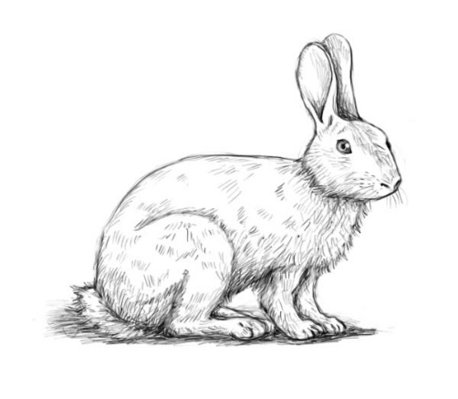

The next three pages are for coloring.

Here are discussion questions to share as you color together:

What did the story say to you?

How did the book make you feel?

What does it mean to become Real?

7

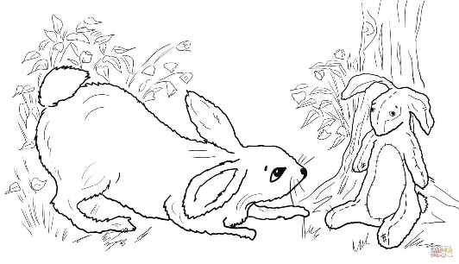

**Activities**

 read the book to your children and have them re-tell the story to you

 have each person in your family create an illustration of a favorite scene of the book

 write a story with a favorite stuffed animal as the main character

 adults – show your children a toy or book or item from your childhood and tell why it is special enough that you have kept it through the years

 find out about the author of *The Velveteen Rabbit* Margery Williams

 adults – tell your children about a toy or item that you always carried to bed when you were young. Show any photos you might have.

 the boy took the Velveteen Rabbit to picnics on their lawn. Have a family picnic and invite toys.

 write a thank-you note to God for our toys and for loving us

6

to come, nor powers, nor height, nor depth, nor anything else in all creation, will be able to separate us from the love of God in Christ Jesus our Lord.”



*One night, and for many nights after, the Rabbit was chosen to sleep with the Boy. The Rabbit was so happy that he never noticed his beautiful velveteen fur was getting shabbier, and his tail coming unsewn, and all the pink rubbed off his nose where the Boy had kissed him.*

You are loved. People who love you overlook your weaknesses and flaws to see your inner beauty. I Peter 4:8 reminds us that “true love covers over a multitude of imperfections because it comes from God, whose love is perfect.”



*One day the little Rabbit heard the Boy tell his Nanny that he was REAL. He was overcome by love in his heart. The next morning the Nanny noticed that there came a look of wisdom and beauty into his boot-button eyes that had long ago lost their polish.*

Being loved by another person changes us. Being loved by God changes us even more, and it shows. 2 Corinthians 3:18 teaches us, “We are transfigured much like the Messiah, our lives gradually becoming brighter and more beautiful as God enters our lives and we become like him.”



*Over time the Rabbit grew older and despite how worn he became the Boy loved him even more. The boy loved him so much that his whiskers fell off and the pink lining to his ears turned grey. The Rabbit even began to lose his shape, and he scarcely looked like a rabbit any more, except to the Boy. To the Boy he was always*

3

*beautiful, because when you are Real, shabbiness doesn’t matter.*

God’s love has the power to renew us no matter what we look like. 2 Corinthians 4:16 instructs us “Even though our outer nature is wasting away, our inner nature is being renewed day by day.”



*Toys, including the Rabbit, were thrown into the rubbish to be burned because the Boy had scarlet fever. The Rabbit reminisced about all of the happy days he had had with the Boy and how happy they were. A great sadness came over him. He seemed to see the days pass before him, each more beautiful than the other, and the wonderful day when he first knew he was Real.*

Do you remember when you lost someone you loved? They are not lost to our Lord who assures us in John 14:1-3, “Do not let your hearts be troubled. Believe in God, believe also in me. In my Father’s house there are many dwelling places. If it were not so, would I have told you that I go to prepare a place for you? And if I go and prepare a place for you, I will come again and will take you to myself, so that where I am, there you may be also.”



*“Of what use was it to be loved and lose one’s beauty and become Real if it all ended like this? And a tear, a real tear, trickled down his little shabby velvet nose and fell to the ground.”*

Death reminds us of our mortality. We can’t change it or prevent it. However, for Christians, death is not the end. I Corinthians 15:42-44 assures us, “So it is with the resurrection of the dead. What is sown is perishable, what is raised is imperishable. It is sown in dishonor, it is raised in glory. It is sown in weakness, it is raised in power. It is sown a physical body, it is raised a spiritual body. If

4

there is a physical body, there is also a spiritual body.”



*A mysterious flower began to grow where the Rabbit’s tear had fallen. It formed into a beautiful flower and blossomed and then opened. A fairy stepped out of it, came up to the Rabbit, and kissed him on his nose. “Little Rabbit,” she said, “I take care of all the playthings that the children have loved. When they are old and worn out and the children don’t need them anymore, then I come and take them away with me and turn them into Real.”*

Our earthly bodies will be transformed into new bodies that will never die. I Corinthians 15:51 & 52 gives us comfort “Listen, I will tell you a mystery! We will not all die, but we will all be changed, in a moment, in the twinkling of an eye, at the last trumpet. For the trumpet will sound, and the dead will be raised imperishable, and we will be changed.”



*“Wasn’t I Real before?” asked the little Rabbit. “You were Real to the Boy,” the Fairy said, “because he loved you. Now you shall be Real to everyone.”*

The Rabbit’s toy body was transformed to a real rabbit’s body. His whiskers grew to touch the grass and his tail moved and his fur had a beautiful sheen. He hopped and played in the grass and joined the other rabbits. Who we are today is but a shadow of who we will be in the future. I Corinthians 15:55 celebrates “Death has been swallowed up in victory. Where, O death, is your victory? Where, O death, is your sting?”

(Parts of pages 2 to 5 were inspired by an article on Beliefnet.com *On being Real* by Bethany Blankley)

5